STANDARD OPERATING PROCEDURE FOR GAS CUTTING
1. PURPOSE: In order to avoid accident and reduce the risk while doing Gas Cutting.
2. SCOPE: These instructions are applicable to Maintenance.
3. RESPONSIBILITY: Maintenance Team, Tool In-charges, Engineer/ HOD
4. SAFETY: All safety precautions will be taken during the execution of this Procedure.
5. SAFE OPERATING PROCEDURE:
5.1. Wear the Personal Protective Equipment’s Safety Helmet, Leather Hand gloves, Safety Goggle, Hand Shield, Leg Guard and Safety Shoe.

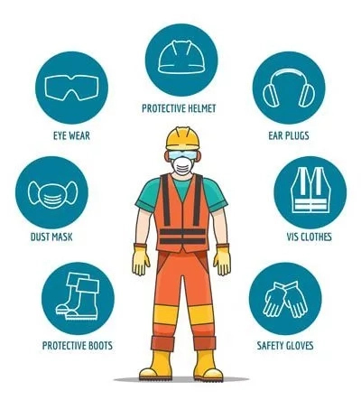

5.2. Keep the work Piece in the safer area/Work Bench. Ensure no Flammable objects or liquid not available Near by the work place

5.3. Keep the Fire Extinguisher around 1 Meter Distance
5.4 Open the O₂ and Acetylene Cylinder, Adjust the regulator for required Pressure.
5.5. Ensure Flash Back Arrestor availability in the Cutting Torch & Regulator.
5.6. Ensure there is no Gas leakage in The Hose & Connector areas
5.7. Slightly open O₂ Valve in the Torch
5.8. Lighten by Using Spark Lighter and adjust the Flame by Opening Acetylene & O₂ Control Valve.
5.9. Place the Torch Near to The Work Piece and Start Heating up to the Work Piece color changing into Red
5.10. Place Torch Near to The Work piece marked area for Cutting
5.11. Keep the Torch at the Starting Point and start heating the marked area.
5.12. After getting red on the edge Slightly Press the Oxygen handle for Pressurized Cutting.
5.13. Once Started Cutting Slightly Move the Torch towards you with Oxygen Handle Pressed condition.
5.14. After Completion of Cutting or Pre heating Close the Torch Valve.
5.15. Keep the Torch in Proper position in the moving Trolley. Ensure Hot nozzle will not touch with Gas Hose.
5.16. Wind the hoses properly.
5.17. Remove the Plug and wind the Cable in the welding Trolley
5.18. Move the machine to location
5.19. Ensure all the tools & Accessories removed from the work place and keep it in

Prepared by: | Reviewed by: | Approved by:

